**ASBAT EXAMINATIONS BOARD**

**MIDTERM II EXAMINATION 2023**

**Age Group (5 – 6 years): TOP CLASS**

**Learning Area 5: Reading**

My name is ______________________________________________

**School: _________________________________________________________**

1. **Match vowels to picture.**

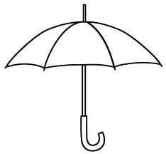a

e

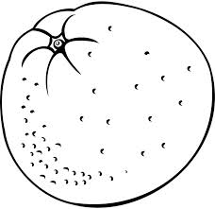

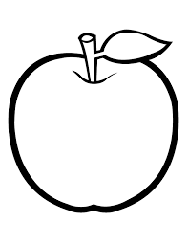

i

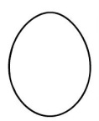

o

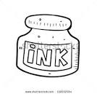

u

1. **Name these pictures.**

|  |  |  |
| --- | --- | --- |
|  | http://www.mormonshare.com/sites/default/files/handouts/fish.gif |  |
|  |  |  |
|  | https://encrypted-tbn3.gstatic.com/images?q=tbn:ANd9GcQWd2W8CUt0581VR8Lu-J0CBvWKjXKdv15yhDjxtYWEIJBDbil1 |  |
|  |  |  |

(flower, rat, pencil, tin, fish, leg)

1. **Fill in the missing syllables.**

ba ____ bi bo bu

pa pe ____ po pu

za ze zi _____ _____

ra ____ ri ro ru

ka ke ____ ko _____

1. **Make words.**

t bet g ________

d ________ ll ________

n ________ n ________

g _______ g ________

n ________ n _______

p ______

1. 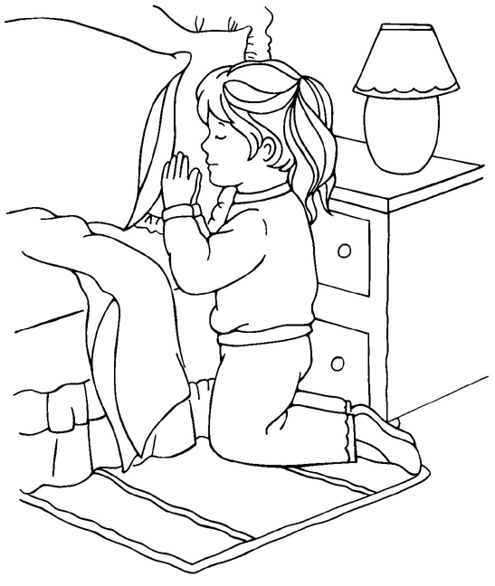**Shade.**
2. **Copy and write.**

**G g G g G g G g**

________________________________________________________________________________________________________________________________________________________________________________________________________________________________________________________________________________________________

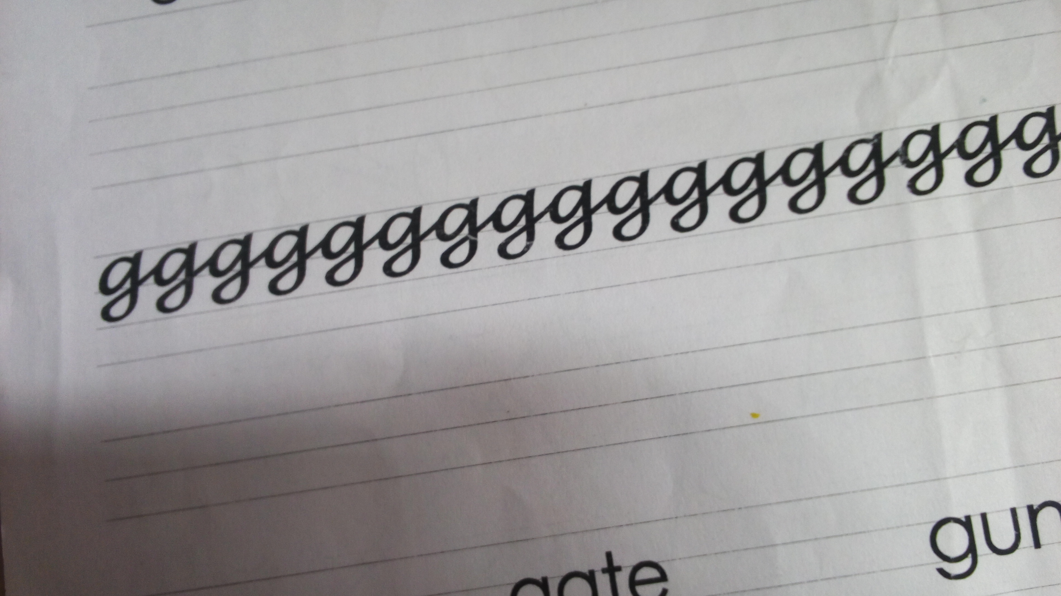

________________________________________________________________________________________________________________________________________________________________________________________________________________________

**girl gate gun**

________________________________________________________________________________________________________________________________________________________________________________________________________________________

**END**